Isaac Venable

CSC3150 Systems Design

System Proposal Part 2

5/21/2024

Professor Andy Cameron

**SmartSplits**



Contents

1.0 Introduction and Overview 3

Problem Statement 3

Project Vision and Scope 3

Requirements Summary 3

Stakeholders and Their Interests 3

Expected Costs and Benefits 3

Constraints 3

Recommendation 3

Document Overview 4

2.0 System Initiation 4

3.0 Feasibility Assessment 6

Introduction 6

Feasibility Analysis 7

**Error! Hyperlink reference not valid.Error! Hyperlink reference not valid.Error! Hyperlink reference not valid.Error! Hyperlink reference not valid.Error! Hyperlink reference not valid.Error! Hyperlink reference not valid.Error! Hyperlink reference not valid.Error! Hyperlink reference not valid.Error! Hyperlink reference not valid.Error! Hyperlink reference not valid.Error! Hyperlink reference not valid.Error! Hyperlink reference not valid.Error! Hyperlink reference not valid.Error! Hyperlink reference not valid.Error! Hyperlink reference not valid.Error! Hyperlink reference not valid.Error! Hyperlink reference not valid.Error! Hyperlink reference not valid.Error! Hyperlink reference not valid.**Conclusion 7

4.0 Requirements Definition 8

Introduction 8

Functional Requirements 8

**Error! Hyperlink reference not valid.Error! Hyperlink reference not valid.Error! Hyperlink reference not valid.Error! Hyperlink reference not valid.Error! Hyperlink reference not valid.Error! Hyperlink reference not valid.**Data Requirements 8

**Error! Hyperlink reference not valid.Error! Hyperlink reference not valid.Error! Hyperlink reference not valid.Error! Hyperlink reference not valid.**Non-functional Requirements 8

**Error! Hyperlink reference not valid.Error! Hyperlink reference not valid.Error! Hyperlink reference not valid.**5.0 Requirements Model 8

Introduction 8

Use-Case Diagram 9

**Error! Hyperlink reference not valid.**Use-Case Descriptions 10

6.0 System Evolution 16

**Error! Hyperlink reference not valid.**7.0 Conclusions and Recommendations 16

**Error! Hyperlink reference not valid.Glossary** 16

**Bibliography** 16

**Executive Summary**

SmartSplits will be an iOS app used to record splits for track and field races and make calculations from those splits to help runners run efficiently. It will be a lightweight app that doesn’t require a large development team. SmartSplits will hopefully become a popular app used across all levels of running and bring more popularity to the sport of track and field.

1.0 Introduction and Overview

## Problem Statement

The customers for SmartSplits will be individual track and field athletes and coaches. A major element of track and field long-distance racing is pacing. Often, runners will not have access to splits, which can negatively impact a race, as a runner might accidentally run too slow or fast during certain parts of the race. Even if a runner has access to basic splits from either a clock or somebody timing them, you still cannot fully utilize that information without performing calculations, which can be difficult to do mentally, especially when one should be focused on the race. In addition to the need for splits during a race, runners can learn a lot about their performance by analyzing their splits after a race, but most of the time, race organizers don’t record splits.

We have an opportunity to build an app that will provide valuable information to track athletes and help them improve and become the best runners they can be. SmartSplits will help current track athletes with the motivation to keep training and give new runners the confidence to try out competitive racing. This could cause track and field to become more popular and motivate people to stay in shape.

## Project Vision and Scope

SmartsSplits’ vision is to give track athletes all the information they need to run their best possible races. SmartSplits will be an app for IOS that can be downloaded from the app store for a small price with no additional costs.

## Requirements Summary

* The app will track a runner’s splits for a race and make useful calculations based on them
* The app will be a place to store and compare splits from previous races
* The app will be easy to use and lightweight

## Stakeholders and Their Interests

Software Development Team – The development team needs the app to generate revenue to fund this and potential future projects.

Individual track athletes – Any person at any point in their running journey could purchase our app to aid in their training and racing.

Track coaches/school programs – SmartSplits will be a useful app for track coaches to help their athletes get better at pacing races, something many beginning runners will need a lot of help with. Partnering with an entire school’s track program could benefit their team while bringing in lots of revenue.

## Expected Costs and Benefits

* If our developers don’t already have MacBooks, we could acquire two for about $1000
* Each developer will cost $7-10k a month
* In our first year after release, we hope to sell 2000 copies monthly at $5, totaling $10k

## Constraints

Small development team – We plan to have only two developers for this app, but the project size means this should be easily completable despite the small team size.

Low budget – We do not have a lot of funding for this project, but we are maximizing what we do have by having a small team and not requiring many external resources.

Recommendation

We have not begun development on this project, and we still require the funding to do so. If you would like to invest in the project or have suggestions, get in contact with one of our team members.

Document Overview

In the rest of this document, the system initiation will be shown, followed by the feasibility assessment, the system requirements, the in-depth requirements model, the system evolution, a conclusion, and finally, the glossary and bibliography.

2.0 System Initiation

PIR-00000 *[PIR Number to be assigned by the Project Office]* Project Initiation Request (PIR)–Level1 v6.0

Project Name: SmartSplits Student Name: Isaac Venable**0. General Project Information**

|  |  |
| --- | --- |
| **Project Name:** | *SmartSplits* |
| **Two Sentence Request Description:** | *SmartSplits will be an application that gives track and field runners and coaches insightful data. It can be used for pre-race planning, mid-race adjustments, and post-race analysis.* |
| **Requested Launch Date(s):** | *4/17/2024* |
| **Department(s) Affected By Project:** | *Computer Science – SPU* |
| **Project’s Customers:** | *Track and Field Athletes & Coaches* |
| **Date Request Submitted:** | 4/16/2024 |

1. **Project Sponsor and Manager**

|  |  |  |  |  |
| --- | --- | --- | --- | --- |
| **Project Sponsor** | |  | **Business Project Manager & Requestor** | |
| **Name:** | Andy Cameron |  | **Name:** | *Isaac Venable* |
| **Title:** | Professor |  | **Title:** | *Project Designer* |
| **Department:** | Computer Science – SPU |  | **Department:** | *Computer Science – SPU* |
| **eMail:** | [acameron@spu.edu](mailto:acameron@spu.edu) |  | **eMail:** | *[venablei@spu.edu](mailto:venablei@spu.edu)* |

1. **Business Problem or Opportunity: The motivation for this request**

*Describe the problem or opportunity that you would like to solve. Include a simple, high-level description of this request’s business problems or opportunities. Focus on the problem or opportunity, not the solution. Be sure to include any date or deadline-related dependencies or needs related to the project.*

| *A major element of track and field long-distance racing is pacing. Often, runners will not have access to splits, which can negatively impact a race, as a runner might accidentally run too slow or fast during certain parts of the race. Even if a runner has access to basic splits from either a clock or somebody timing them, you still cannot fully utilize that information without performing calculations, which can be difficult to do mentally, especially when one should be focused on the race. In addition to the need for splits during a race, runners can learn a lot about their performance by analyzing their splits after a race, but most of the time, race organizers don’t record splits.* |
| --- |

1. **Justification, Impact, and Importance**

*What is the financial impact and justification for this request? How will the investment of time, resources, and capital be returned to our company? (Please note any contractual or regulatory requirements associated with the request. If you have an NPV, IRR, or ROI calculation, please provide the link(s) in this section.)*

**Assumptions**

|  |
| --- |
| * *The runner will have a phone they can bring on race day.* |
| * The runner will have somebody who can use their phone to record splits and read off information. |

**Competitive Landscape / Context**

|  |
| --- |
| * *There are some basic split timer apps on the App Store currently.* |
| * Some physical auto-splitters can be bought online. |

**Tangible Return, Opportunity, or Value One Time On-Going**

|  |  |  |
| --- | --- | --- |
| * The runner will achieve better times by running more consistent races. | $0 | $0 |
| * The runner can keep all their race times and splits in one place. | $0 | $0 |

**Intangible Benefits Impact or Value**

|  |  |
| --- | --- |
| * *The runner feels less nervous during the race because they know their exact pace.* | $0 |
| * Coaches can give better mid-race advice. | $0 |

1. **Product Requirements**

*The Project team will gather detailed requirements once the project is approved. Use this section to articulate the critical solution components to help scope the project’s size and complexity. Do not describe how the solution will be implemented; instead, only list the functionality or results you expect to receive when the product is complete/delivered.*

* 1. **Must Haves**

|  |
| --- |
| * + 1. *The app calculates exactly what split times you need to run to hit a goal time, updating after each split.* |
| * + 1. The app calculates the time you would run if you continued the race running at the exact pace as your last split. |
| * + 1. The app calculates the time you are on track to run based on average splits at a certain point. |
| * + 1. The app allows you to save your race splits and go back to view them. |
| * + 1. The app has sound effects based on whether you are ahead of pace or behind. |

* 1. **Could Haves** (Nice to Haves)

|  |
| --- |
| * + 1. *The app could have the ability to track splits for multiple runners at once.* |
| * + 1. The app could allow the runner to account for a “kick” at the end of the race, and the calculations could be adjusted to anticipate a fast last lap. |
| * + 1. The app could have a text-to-speech feature to read off your splits and other details. |
| * + 1. The app could give workout suggestions after a race based on the results. |

* 1. **Won’t Haves** (Don’t Do’s, aka Out of Scope)

|  |
| --- |
| * + 1. *Will not try to create auto-splitting.* |
| * + 1. Will not be able to split using a running watch. |

3.0 Feasibility Assessment

Introduction

This section will discuss the feasibility of SmartSplits in 6 different areas: technical, resource, schedule, organizational, legal, and contractual. Feasibility will be graded on a scale from ideal to good to poor, and risk will be graded on a scale from low to medium to high.

Feasibility Analysis

**Technical Feasibility**

* Users will be very familiar with our app, as the controls will be similar to the basic stopwatch on the clock app. The UI will also be customizable to show exactly what data the user wants to see. Feasibility here is **ideal**.
* Our development team will already be very experienced in IOS app development, so feasibility here is also **ideal**.
* The app is fairly small, so it is feasible to do with only a couple of developers.
* Overall, the technical feasibility is **ideal.**

**Resource Feasibility**

* Very little resources will need to be acquired for this project, so resource feasibility is **ideal**

**Schedule Feasibility**

* Optimally, SmartSplits would launch before the next indoor track season, which starts in December 2024
* This is far more time than needed to complete the app, so schedule feasibility is **ideal**

**Organizational Feasibility**

* Our app depends on individual athletes deciding to download it, and since we have no way to guarantee that a certain number of people will, this is a **high** risk
* Our app will also need to partner with track programs, which may not decide to partner with us if they don’t think our app will benefit them, so this is a **medium** risk
* There are over 4 million track athletes in the US, so this large market size reduces the risks of not having enough customers
* Overall, the organizational feasibility is **good**. While there are a few risks of not having a good market, this risk is minimal because there are so many potential users that even getting a very small percentage of them to get the app would mean massive profits

**Legal Feasibility**

* There are no legal issues that will affect SmartSplits, so legal feasibility is **ideal**

**Contractual Feasibility**

* There are no contract issues that will affect SmartSplits, so contractual feasibility is **ideal**

Conclusion

Overall, the feasibility of SmartSplits is **ideal.** Nearly every area of feasibility for the app is ideal, and there are very few risks to worry about.

4.0 Requirements Definition

Introduction

This section discusses the functional and non-functional attributes of the system. The functional requirements have to do with what the app is actually doing, while non-functional attributes are just a part of the system that doesn’t directly do anything.

Functional Requirements

1. Record Splits – The app can record splits at different intervals for track races of any length.
2. On Pace For – The app determines what a runner is on pace to run, based on either average or most recent split.
3. Splits Needed – The app determines what a runner needs to run for each split based on previous splits and a goal time.
4. Split Comparison – The app can determine how much a runner is ahead or behind their previous races at any point in a race.
5. Save Splits – The app stores all races and splits in a database the user can access and analyze.
6. Pace Notifications – The app has different sound effects based on whether the runner is on pace.

Data Requirements

* The app stores race results, including splits
* The race distance and split distance will be stored as integers
* The finishing time for the race will be stored as a float
* The splits will be stored as a string in JSON format

Non-functional Requirements

* The app will be easy to navigate
* The app will not take too much space (max 20MB)
* The app will have a unique and recognizable brand/styling

5.0 Requirements Model

Introduction

This section discusses the requirements of the system in further detail. The Use-Case Diagram shows how the requirements interact with the different actors of the system, and then the Use-Case descriptions go in-depth on each of the system’s use cases.

Use-Case Diagram

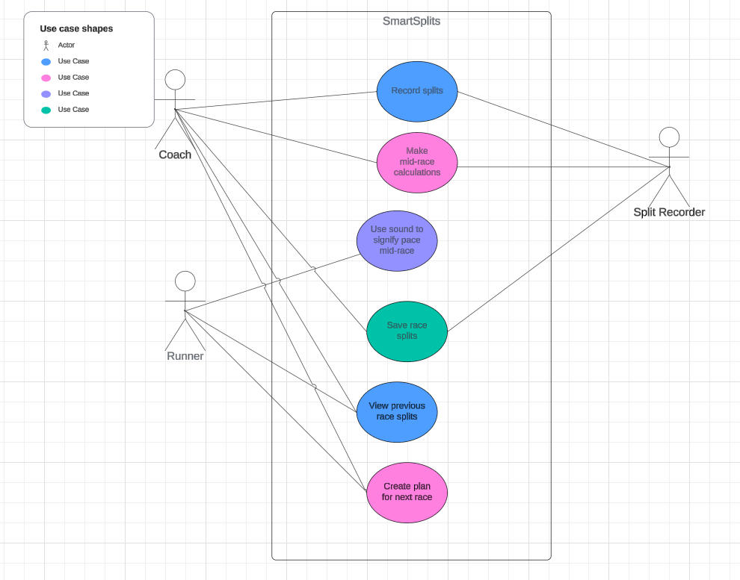

Use-Case Descriptions

|  |  |  |  |
| --- | --- | --- | --- |
| **Use Case Name**: Record Splits | | **ID**: 01 | **Importance**: Must Have |
| **Primary Actor**: Coach/Split Recorder | **Use Case Type**: Essential | | |
| **Supporting Actors:** | | | |
| **Stakeholders and Interests**:  The runner will see improvements in their race by having splits recorded for them. | | | |
| **Brief Description**:  Either a coach or other split recorder can time and record splits for a runner for a race of any distance and splits of any size. | | | |
| **Trigger**: When the start race button is selected, and when the split button is selected mid-race  **Type** (mark one): _x__ External ___ Temporal | | | |
| **Relationships**:  **Association**: Gives the runner information during and after their race  **Include**: N/A  **Extend**: This is used in making the mid-race calculations and saving splits.  **Generalization**: N/A | | | |
| **The Normal Flow of Events**:   1. Split recorder or coach starts the race 2. The split button is pressed once per lap to record splits 3. On the last split, the race timer stops, and the list of splits can be viewed | | | |
| **Sub-flows**: | | | |
| **Alternate/Exceptional Flows**:   * If the splitter accidentally splits twice, they can undo a split * If the splitter misses a split, they can skip the split * You can cancel the race | | | |
| **Special Requirements:** | | | |
| **To do/Issues:** | | | |

|  |  |  |  |
| --- | --- | --- | --- |
| **Use Case Name**: Make mid-race calculations | | **ID**: 02 | **Importance**: Must have |
| **Primary Actor**: Coach/Split Recorder | **Use Case Type**: Essential | | |
| **Supporting Actors:** | | | |
| **Stakeholders and Interests**:  The runner will be able to make mid-race adjustments based on these calculations. | | | |
| **Brief Description**:  The app makes various calculations based on the splits during a race: currently on pace for (based on last split), on pace for (based on average split), splits needed to hit goal time, time ahead/behind goal pace, and potentially more. | | | |
| **Trigger**: After each split is made in a race  **Type** (mark one): _x__ External ___ Temporal | | | |
| **Relationships**:  **Association**: The runner will get valuable information from the calculations  **Include**: Uses the record splits feature  **Extend**: N/A  **Generalization**: N/A | | | |
| **The Normal Flow of Events**:   1. The coach or split recorder hits split 2. The app makes calculations 3. The results are displayed | | | |
| **Sub-flows**: | | | |
| **Alternate/Exceptional Flows**: | | | |
| **Special Requirements:** | | | |
| **To do/Issues:** | | | |

|  |  |  |  |
| --- | --- | --- | --- |
| **Use Case Name**: Sound Effects Signals | | **ID**: 03 | **Importance**: Must Have |
| **Primary Actor**: Runner | **Use Case Type**: Essential | | |
| **Supporting Actors:** Coach/Split Recorder | | | |
| **Stakeholders and Interests**:  The runner will get some information about their splits even if they don’t have someone reading them off for them. | | | |
| **Brief Description**:  Various sounds can play depending on how fast or slow the runner is compared to their goal pace. This could be upgraded to a full text-to-speech reading of the information. | | | |
| **Trigger**:  **Type** (mark one): _x__ External ___ Temporal | | | |
| **Relationships**:  **Association**: The runner gets some information during the race  **Include**: Uses the pace calculations  **Extend**: N/A  **Generalization**: N/A | | | |
| **The Normal Flow of Events**:   1. Split is recorded 2. Pace is calculated 3. Appropriate sound/text-to-speech is played | | | |
| **Sub-flows**: | | | |
| **Alternate/Exceptional Flows**:   * In scenarios of completely impossible paces(in case of double splitting), no sound will play | | | |
| **Special Requirements:** | | | |
| **To do/Issues:** | | | |

|  |  |  |  |
| --- | --- | --- | --- |
| **Use Case Name**: Save race splits | | **ID**: 04 | **Importance**: Must Have |
| **Primary Actor**: Coach/Split Recorder | **Use Case Type**: Essential | | |
| **Supporting Actors:** | | | |
| **Stakeholders and Interests**:  The coach and runner will be able to look over previous races together to create better race and training plans | | | |
| **Brief Description**:  The splits recorded from the race will be saved to a database | | | |
| **Trigger**: After a race if the “save” button is clicked  **Type** (mark one): _x__ External ___ Temporal | | | |
| **Relationships**:  **Association**: The runner and coach will want the race data saved to analyze later  **Include**: Uses the recorded splits  **Extend**: These splits will be viewable later  **Generalization**: N/A | | | |
| **The Normal Flow of Events**:   1. Race is started 2. Splits get recorded 3. Race finishes 4. The coach/split recorder hits the save button | | | |
| **Sub-flows**:   1. After hitting the save button, the splits are converted into a JSON-formatted string 2. The string and some other data about the race are added to the database | | | |
| **Alternate/Exceptional Flows**: | | | |
| **Special Requirements:** | | | |
| **To do/Issues:** | | | |

|  |  |  |  |
| --- | --- | --- | --- |
| **Use Case Name**: View previous race splits | | **ID**: 05 | **Importance**: Must Have |
| **Primary Actor**: Runner | **Use Case Type**: Essential | | |
| **Supporting Actors:** Coach | | | |
| **Stakeholders and Interests**:  The runner will want to be able to review their performance to see what could be improved. The coach will also be able to review the splits to adjust training and race plans for the runner. | | | |
| **Brief Description**:  Results from previously saved races will be available for analysis. | | | |
| **Trigger**: The runner will navigate through their list of saved races and select one to view  **Type** (mark one): _x__ External ___ Temporal | | | |
| **Relationships**:  **Association**: The runner will be able to view their splits  **Include**: Needs the save splits feature in order to have anything to display  **Extend**: Can be used in the create race plan feature  **Generalization**: N/A | | | |
| **The Normal Flow of Events**:   1. A race is saved and added to the database 2. The runner looks through their list of saved races and selects one 3. The splits from that race are brought up and can be analyzed | | | |
| **Sub-flows**:   1. During analysis, the runner could create a new race plan if they want | | | |
| **Alternate/Exceptional Flows**: | | | |
| **Special Requirements:** | | | |
| **To do/Issues:** | | | |

|  |  |  |  |
| --- | --- | --- | --- |
| **Use Case Name**: Create a race plan | | **ID**: 06 | **Importance**: Must Have |
| **Primary Actor**: Runner | **Use Case Type**: Essential | | |
| **Supporting Actors:** Coach | | | |
| **Stakeholders and Interests**:  The runner and coach can use this feature to better prepare the runner for future races | | | |
| **Brief Description**:  Based on either goal times or previous races, the app can generate a pace guide for the runner to use, and they can use the app to compare their race to the race plan while they run | | | |
| **Trigger**: When the runner selects “create a new race plan”  **Type** (mark one): __x_ External ___ Temporal | | | |
| **Relationships**:  **Association**: The runner will be able to use the race plans at their next race  **Include**: Includes the previously saved race splits  **Extend**: This can be used during the pace calculations if the runner chooses to “race” against the race plan  **Generalization**: N/A | | | |
| **The Normal Flow of Events**:   1. The runner starts the race plan creation process with either a goal time or a previous race 2. The runner then can adjust the splits if they deem necessary 3. The runner can save the race plan to run against later (it gets saved in the same format as a regular race) | | | |
| **Sub-flows**:   1. When creating the plan, there will be additional settings that can be adjusted, such as whether you want to positive-split or negative-split, and if you have a really fast last lap | | | |
| **Alternate/Exceptional Flows**:   * If the runner tries to create a race plan with impossible splits (too fast, negative splits, etc.), it will not save | | | |
| **Special Requirements:** | | | |
| **To do/Issues:** | | | |

6.0 System Evolution

A few additional features may be added to SmartSplits in the future. One feature already mentioned was the possibility of a text-to-speech reading of the calculations during the race, which would help the runners get the information they need in a quick, standardized way. Another potential feature would be the ability to get splits for multiple runners at once in the same race, which would be especially helpful for coaches and make the app very marketable to high school track teams. Another feature would be for the app to give workout suggestions for the runner based on the results, making the app more marketable as a multi-purpose running tool.

7.0 Conclusions and Recommendations

SmartSplits is a small and relatively inexpensive application with a lot of potential. With a goal of helping runners everywhere run their best possible performances, SmartSplits could increase runner’s investments in track and field and get new people into the sport. It will be a very useful tool for runners of all skill levels. It can serve almost as a basic running coach for those who are just getting started. For experienced runners, the advanced settings and metrics will allow them to maximize their training and race efforts.

# **Glossary**

Split: In track and field, split is the term for a runner to run a small part of their race, usually one lap

XCode: A popular IDE for MacBooks and other Apple products

# **Bibliography**

Cameron, A. Various CSC 3150 Lectures.